OS LAB 14

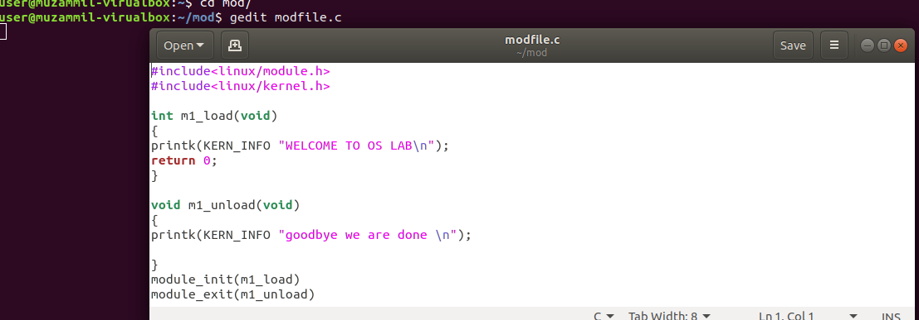
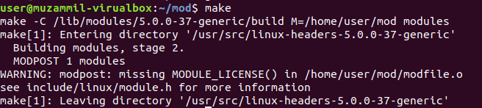
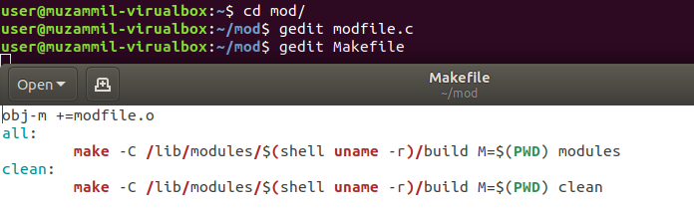

output

FOR MODULE 2

source file
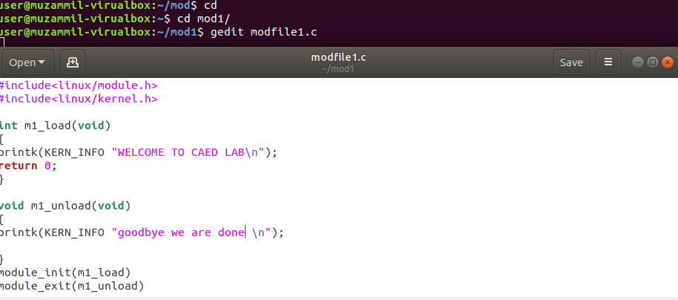
Same make file for mule 2 as well
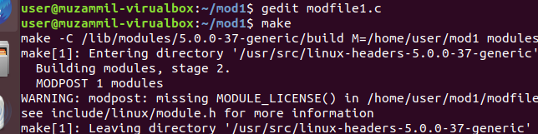
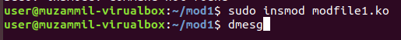

output
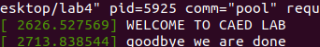

COMPLETE OUTPUT
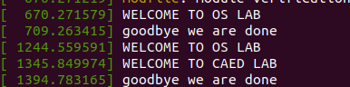

Note: Ma’am my laptop isn’t working so I did this lab on Muzammil’s laptop.

